Types of Synonyms
# Source: AI Source: Provided by: [Data Path: Persons Table -> ID Column: 1, Name_En Column: Motasem Essam] -> From: [Chatgpt (GPT-4-turbo)] on [7/30/2025]
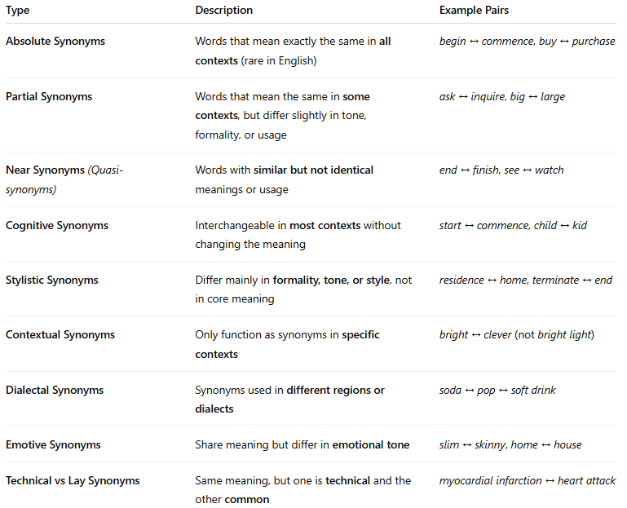

Type | Description | Example Pairs
Absolute Synonyms | Words that mean exactly the same in all contexts (rare in English) | begin ↔ commence, buy ↔ purchase
Partial Synonyms | Words that mean the same in some contexts, but differ slightly in tone, formality, or usage | ask ↔ inquire, big ↔ large
Near Synonyms (Quasi-synonyms) | Words with similar but not identical meanings or usage | end ↔ finish, see ↔ watch
Cognitive Synonyms | Interchangeable in most contexts without changing the meaning | start ↔ commence, child ↔ kid
Stylistic Synonyms | Differ mainly in formality, tone, or style, not in core meaning | residence ↔ home, terminate ↔ end
Contextual Synonyms | Only function as synonyms in specific contexts | bright ↔ clever (not bright light)
Dialectal Synonyms | Synonyms used in different regions or dialects | soda ↔ pop ↔ soft drink
Emotive Synonyms | Share meaning but differ in emotional tone | slim ↔ skinny, home ↔ house
Technical vs Lay Synonyms | Same meaning, but one is technical and the other common | myocardial infarction ↔ heart attack

